
Kaikaute Ahumoni
Financial Accountant
Job Description

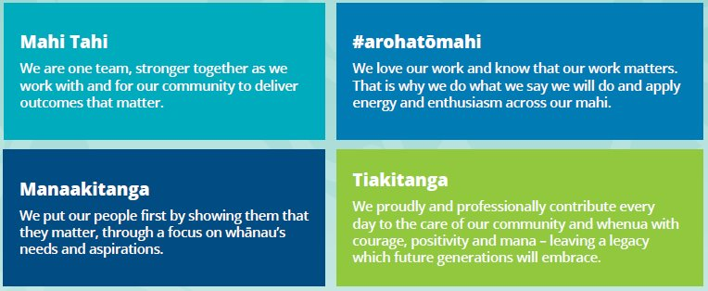
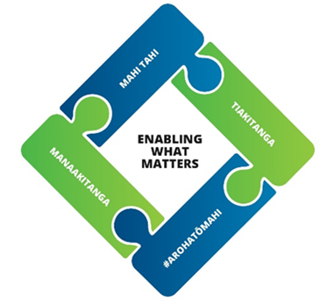

Details
Job Title | Financial Accountant - Kaikaute Ahumoni
REPORTS TO | Finance Manager
GROUP | Organisation Performance
INDIRECT REPORTS | None
FINANCIAL DELEGATIONS | TBC
WARRANTS REQUIRED | None
GRADE | 18

Purpose
Horowhenua District Council is responsible for delivering services and infrastructure that support the wellbeing and future prosperity of our communities. Sound financial management, transparent reporting and effective stewardship of public resources are fundamental to achieving this.
The Finance team supports Council to make informed decisions, meet its statutory obligations and maintain the financial sustainability of the organisation.
The Financial Accountant plays a key role in ensuring the accuracy, integrity and reliability of Council's financial information. The position leads the technical preparation and coordination of financial reporting, including monthly and annual financial statements, statutory disclosures, audit requirements and complex accounting matters.
Working closely with the Finance Manager and wider organisation, the role provides technical accounting expertise, maintains effective financial controls and drives improvements in financial systems, processes and reporting.
The role requires someone who can work independently, exercise sound professional judgement, manage competing deadlines and translate complex accounting information into clear, meaningful advice.

Key Responsibility and Expected Outcomes
Financial reporting and statutory compliance
- Lead the preparation of accurate, timely monthly, quarterly and annual financial statements and supporting schedules.
- Ensure reporting complies with Public Benefit Entity accounting standards, generally accepted accounting practice and relevant legislation, including the Local Government Act 2002.
- Prepare and review complex reconciliations, journals, accounting adjustments and working papers.
- Identify and resolve accounting issues before they affect reporting quality or delivery timelines.
Annual report and external audit
- Coordinate the financial components of the Annual Report, including financial statements, accounting policies, statutory disclosures and supporting schedules.
- Maintain audit lead schedules, reconciliations and supporting documentation, with a clear audit trail for significant judgements, estimates and transactions.
- Coordinate accurate, timely responses to audit queries and work proactively with auditors to resolve technical matters and minimise delays, rework and cost.
- Support the Finance Manager to address audit findings and continuously improve the annual reporting and audit process.
Financial controls and balance sheet integrity
- Maintain a robust balance sheet reconciliation framework with clear ownership, review processes and timely resolution of outstanding items.
- Oversee the general ledger and monitor the integrity of financial data and accounting treatments.
- Ensure accounting processes are documented, consistently applied and supported by effective internal controls, recommending practical improvements where weaknesses are found.
- Support compliance with Council's financial policies, delegations and statutory requirements.
- Identify emerging reporting risks and escalate significant matters promptly.
Treasury, assets and technical accounting
- Support accounting, reconciliations and disclosures for Council's borrowings, investments, financial instruments and treasury activities.
- Support accounting for property, plant and equipment (capitalisation, depreciation, disposals, impairment, revaluations and vested assets), working with asset management and operational teams to ensure infrastructure asset information is accurately reflected.
- Provide technical accounting advice on provisions, commitments, leases and other complex or non-routine transactions, including those arising from organisational change or legislative reform.
Financial planning and organisational support
- Support the preparation of financial information for the Long Term Plan, Annual Plan and other planning processes, ensuring consistency with planning assumptions, accounting policies and statutory requirements.
- Assist with financial analysis, forecasting and interpretation of results, and provide technical support to Finance Business Partners and Finance team members.
- Explain complex accounting matters clearly to non-accountants and help operational teams improve the quality and timeliness of financial information.

Collaboration and professional leadership
- Provide technical guidance, coaching and peer review to Finance team members.
- Build effective working relationships across Finance, asset management, corporate planning and operational teams.
- Take ownership of deliverables and proactively communicate risks, issues and progress.
- Contribute to a respectful, collaborative, solutions-focused team, showing professionalism, integrity and sound judgement with confidential or sensitive information.
Relationship Management
- Support the Organisation Performance Group in strengthening Council’s strategic relationships by working collaboratively with Iwi and other cultural stakeholders.
- Establish and maintain a network of key contacts to enhance Council’s relationships across local government, government agencies, businesses, and the community.
- Coordinate the implementation of communication plans to ensure key stakeholders are kept informed of Council’s work programme.
Health Safety & Wellbeing
- Promote a strong health and safety culture by proactively modelling our values and hold self and others to account to consistently follow all health and safety policies and legislative requirements.

Council Contribution
- Actively contribute to the Organisation Performance Group by performing duties as required, promoting a positive workplace culture, and participating in Emergency Management activities.

CAPABILITY & COMPETENCIES REQUIRED
SkillS, knowledge & Experience | - A tertiary qualification in accounting, finance or a related discipline.  - Chartered Accountant (CA ANZ) status or an equivalent recognised accounting designation, with a commitment to ongoing professional development.  - At least five years' relevant accounting experience, including financial reporting, preparing financial statements and supporting external audits.  - Strong working knowledge of financial accounting standards.  - Experience preparing and reviewing balance sheet reconciliations, journals and complex accounting calculations.  - Experience using financial management systems and advanced Excel.  - Ability to manage reporting deadlines and competing priorities with limited supervision.  - Experience improving financial processes and controls.  - Desirable: experience in local government, the wider public sector or a complex asset-intensive environment.  - Desirable: knowledge of New Zealand Public Benefit Entity accounting standards, the Local Government Act 2002 and local authority reporting.  - Desirable: infrastructure asset, treasury or financial instrument accounting.  - Desirable: contributing to Annual and Long Term Plans, and coaching other accounting professionals.

Drives Community Outcomes
Delivers impactful outcomes for the community by providing exceptional service, fostering meaningful Iwi relationships, integrating Te Reo Māori and tikanga, and continuously improving efficiency within the Horowhenua District Council landscape.
Delivery Focused
Delivers high-quality work with integrity, accountability, and efficiency, following through on commitments, engaging with Iwi where appropriate, and using digital tools effectively to achieve meaningful community outcomes.
Mana Enhancing
Builds trust by placing people at the heart of decisions, embracing diverse cultures, upholding high standards of professionalism, nurturing personal growth and self-care, and protecting the mana and integrity of relationships.
Connected
Builds strong, trust-based relationships across teams and the community through clear communication, collaboration, and cultural engagement, creating a connected and inclusive environment that drives better outcomes.
Resilient and Adaptable
Adapts to change with curiosity and resilience, maintaining focus under pressure, seeking diverse perspectives, and persevering to deliver the best outcomes for the community.

Alignment with our community outcomes
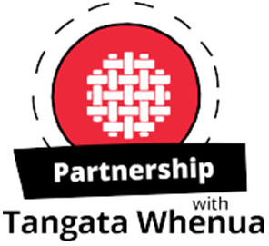 | We uphold Te Tiriti o Waitangi and its principles and recognise the role of Mana Whenua as kaitiaki of their rohe. We support them to maintain and enhance tikanga with their ancestral lands and waterways, wāhi tapu and other taonga, and build mutually respectful partnerships with tangata whenua, supporting whanau, marae, hapū and iwi in achieving their aspirations.
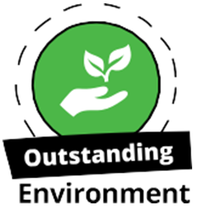 | We contribute to improving our natural environment for current and future generations to enjoy, and protect the important natural features in our district.  We ensure our built environment supports the wellbeing of our people and manage competing pressures on resources sustainably.
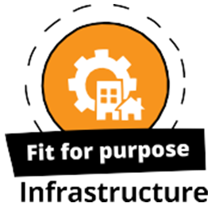 | We provide efficient, reliable and affordable infrastructure, developing and maintaining facilities and infrastructure to meet the needs of current and future generations. Our community facilities and infrastructure are resilient, helping us to respond to climate change and natural hazards, working with partners to develop infrastructure that enables growth.
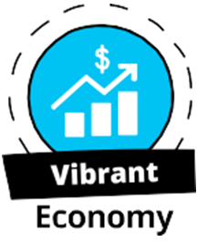 | We are business friendly, supporting diversity and resilience in our local economy and work with others to make our economy grow. We aspire for economic security for all of our people and seize growth opportunities for our district.
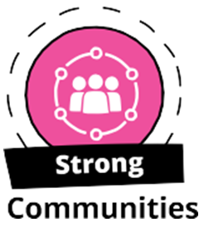 | We value the diversity of our people, and how our district’s heritage shapes our community’s sense of identity and pride.  We provide infrastructure, services, facilities and places to build resilient and connected communities where people of all ages and backgrounds feel included and safe. We are building collaborative relationships with service providers to enable all people to live positive and healthy lifestyles, encouraging our people to participate in local decision making.

