
Customer Experience Ambassador
Job Description
Kanohi Whakawhanaunga Kiritaki

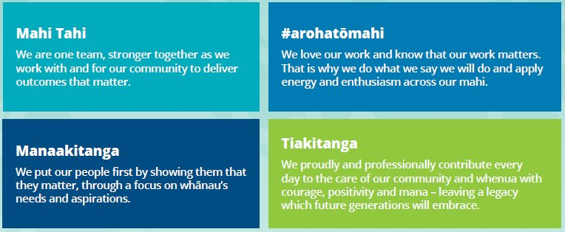
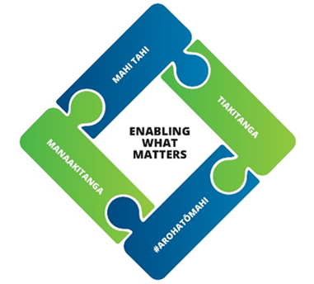

Details
Job Title | Customer Experience Ambassador
REPORTS TO | Customer Service Team Lead
GROUP | Community Experience and Services
DIRECT REPORTS | Nil
FINANACIAL DELEGATIONS | TBC
WARRANTS REQUIRED
GRADE | 10,11

Purpose
The Customer Experience Team are the face of the Council, this is the first stop for all of the Community with any of the services we provide. You will be the face and voice of Council for our community through face to face, telephone and digital communications
As a member of the Customer Experience Team you are responsible and accountable for providing and the delivery of excellent Customer Service. . You will strive to go above and beyond to exceed expectations by being reliable, detail focused and meticulous.
Follows through on plans to ensure they are carried out accordingly, support and collaborate with team members to achieve targets.
This role will have times of pressure and requires a calm, composed, and optimistic approach in stressful or high-pressure situations.
Key Responsibility and Expected Outcomes
Customer Centric Processes & Procedures
- Know the Customer Excellence Strategy and apply as directed, while ensuring customer service is at the forefront of all decisions.
- Ensure services are delivered in an effective and customer focused way while maintaining working relationships.
- Accurately process financial transactions and reconcile all payments at the end of each day through reporting.
- Administer and process documentation as per Council standards and procedures.
- Follow processes and procedures ensuring all documentation is completed and recorded as per Council policies with accuracy.
- Provide a professional, friendly and helpful customer experience to all customers, contractors and staff while managing customer expectations. Guiding them to get the information or services they need providing an in-depth service of advice or transactions or directing queries and jobs to relevant departments when required.
- Act as a liaison between customers, contractors and or back-office staff, assist customers with Council procedures and policies. Lodge all requests within required timeframes through official processes and followed up on when needed.

Information Tracking, Reporting & Support
- Gather and report on all customer related information as per set department requirements.
- Provide reporting through relevant tasks or when directed by your Team Lead or Manager.
- Provide high level support services to the overall Customer Experience department.
- Identify value added improvement ideas or give feedback on ideas when presented to you to ensure the Customer Experience Team are working effectively and efficiently

Relationship Management
- Support the (role specific) Group in strengthening Council’s strategic relationships by working collaboratively with Iwi and other cultural stakeholders.
- Establish and maintain a network of key contacts to enhance Council’s relationships across local government, government agencies, businesses, and the community.
- Coordinate the implementation of communication plans to ensure key stakeholders are kept informed of Council’s work programme.

Health Safety & Wellbeing
- Promote a strong health and safety culture by proactively modelling our values and hold self and others to account to Consistently follow all health and safety policies and legislative requirements.
- Hold self and others to account
- Consistently follow all Health and Safety policies and legislative requirements.
- Ensure appropriate the relevant GM is briefed on serious or significant Health and Safety incidents; immediately in the event of a major incident.
- Work-related accidents, incidents and illnesses are reported through Pour H&S system.

Council Contribution
- Actively contribute to the Community Experience & Services Group by performing duties as required, promoting a positive workplace culture, and participating in Emergency Management activities.

SkillS, knowledge  & Experience | - Minimum Qualification of NCEA level 1.  - Minimum of Restricted Driver license  - At least 2 years in a Customer Service facing role  - Experience working in a contact centre or Customer or business administration related qualification preferred but not essential. Ability to communicate in a clear manner with people from all walks of life.  - Proven experience in a call centre and dealing with multiple tasks on a daily basis.  - Demonstrates sound organisational skills and a high level of time management to ensure tasks are completed on time. High level of attention to detail and accuracy.  - Demonstrates a strong focus on high performance and personal achievement Capable of dealing with conflict in a positive manner.  - Is aware of own strengths and weaknesses and actively seeks out opportunities for new learning and growth.  - Takes a big-picture, long-term view when planning and anticipating potential impacts on the business. Weighs up options and implications, identifies strategies and plans, and is comfortable with managed risks.  - Maximise returns in the business is future-orientated and strategic and seeks areas for business improvement.  - Has a desire to learn more and is able to learn new information and skills quickly. Is able to apply learnt information to new problems. Quick to pick up technical concepts and jargon..
CAPABILITY & COMPETENCIES REQUIRED
Drives Community Outcomes
Delivers impactful outcomes for the community by providing exceptional service, fostering meaningful Iwi relationships, integrating Te Reo Māori and tikanga, and continuously improving efficiency within the Horowhenua District Council landscape.
Delivery Focused
Delivers high-quality work with integrity, accountability, and efficiency, following through on commitments, engaging with Iwi where appropriate, and using digital tools effectively to achieve meaningful community outcomes.
Mana Enhancing
Builds trust by placing people at the heart of decisions, embracing diverse cultures, upholding high standards of professionalism, nurturing personal growth and self-care, and protecting the mana and integrity of relationships.
Connected
Builds strong, trust-based relationships across teams and the community through clear communication, collaboration, and cultural engagement, creating a connected and inclusive environment that drives better outcomes.
Resilient and Adaptable
Adapts to change with curiosity and resilience, maintaining focus under pressure, seeking diverse perspectives, and persevering to deliver the best outcomes for the community.

Alignment with our community outcomes
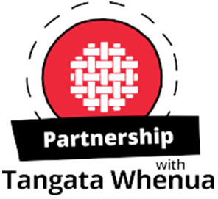 | We uphold Te Tiriti o Waitangi and its principles and recognise the role of Mana Whenua as kaitiaki of their rohe. We support them to maintain and enhance tikanga with their ancestral lands and waterways, wāhi tapu and other taonga, and build mutually respectful partnerships with tangata whenua, supporting whanau, marae, hapū and iwi in achieving their aspirations.
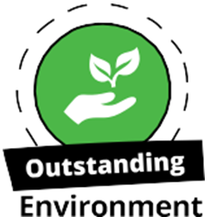 | We contribute to improving our natural environment for current and future generations to enjoy, and protect the important natural features in our district.  We ensure our built environment supports the wellbeing of our people and manage competing pressures on resources sustainably.
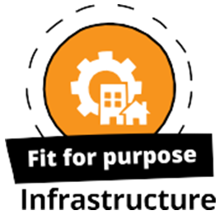 | We provide efficient, reliable and affordable infrastructure, developing and maintaining facilities and infrastructure to meet the needs of current and future generations. Our community facilities and infrastructure are resilient, helping us to respond to climate change and natural hazards, working with partners to develop infrastructure that enables growth.
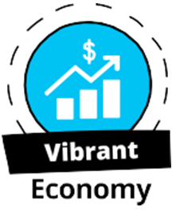 | We are business friendly, supporting diversity and resilience in our local economy and work with others to make our economy grow. We aspire for economic security for all of our people and seize growth opportunities for our district.
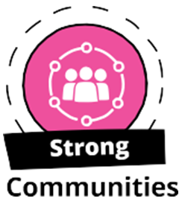 | We value the diversity of our people, and how our district’s heritage shapes our community’s sense of identity and pride.  We provide infrastructure, services, facilities and places to build resilient and connected communities where people of all ages and backgrounds feel included and safe. We are building collaborative relationships with service providers to enable all people to live positive and healthy lifestyles, encouraging our people to participate in local decision making.

